1 run

training 1 epoch...

1797.8732960224152 seconds used......

1 training finished! average train loss: 0.829718264038386

total clf loss: 1055.285537591204 total adv loss: 620.369539967156 667.658195247408

evaluating...

Confusion matrix, without normalization

[[ 385 281 356]

[ 221 4883 303]

[ 85 289 10391]]

Normalized confusion matrix

[[0.37671233 0.27495108 0.34833659]

[0.04087294 0.90308859 0.05603847]

[0.00789596 0.02684626 0.96525778]]

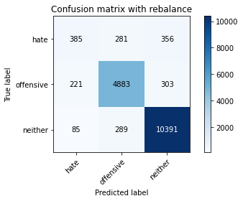

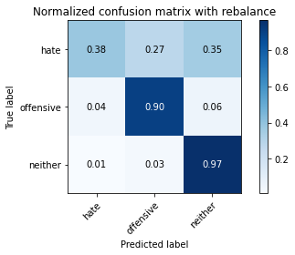

precision recall f1-score support

hate 0.56 0.38 0.45 1022

offensive 0.90 0.90 0.90 5407

neither 0.94 0.97 0.95 10765

accuracy 0.91 17194

macro avg 0.80 0.75 0.77 17194

weighted avg 0.90 0.91 0.91 17194

average eval_loss: 0.28488902495091045, accuracy: 0.910724671396999

training 2 epoch...

1798.895670413971 seconds used......

2 training finished! average train loss: 0.6524674127627673

total clf loss: 839.9327353714034 total adv loss: 482.7363120777445 522.5345192351379

evaluating...

Confusion matrix, without normalization

[[ 379 369 274]

[ 163 5054 190]

[ 309 422 10034]]

Normalized confusion matrix

[[0.37084149 0.36105675 0.26810176]

[0.03014611 0.93471426 0.03513963]

[0.02870413 0.03920111 0.93209475]]

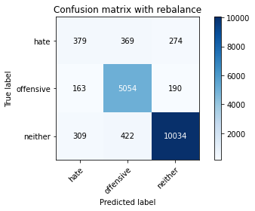

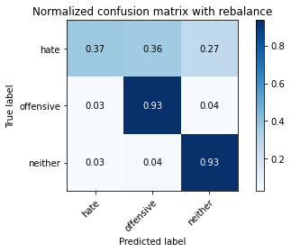

precision recall f1-score support

hate 0.45 0.37 0.40 1022

offensive 0.86 0.93 0.90 5407

neither 0.96 0.93 0.94 10765

accuracy 0.90 17194

macro avg 0.76 0.75 0.75 17194

weighted avg 0.90 0.90 0.90 17194

average eval_loss: 0.30588039515193466, accuracy: 0.8995579853437246

training 3 epoch...

1799.446988105774 seconds used......

3 training finished! average train loss: 0.5139842576035314

total clf loss: 663.9093283251859 total adv loss: 379.18674343415216 412.95488090231083

evaluating...

Confusion matrix, without normalization

[[ 490 301 231]

[ 358 4902 147]

[ 520 507 9738]]

Normalized confusion matrix

[[0.47945205 0.29452055 0.2260274 ]

[0.06621047 0.90660255 0.02718698]

[0.04830469 0.04709707 0.90459824]]

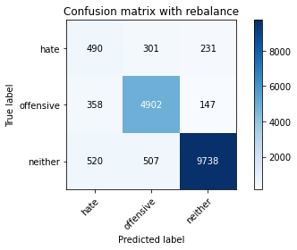

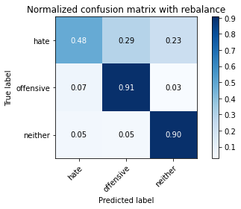

precision recall f1-score support

hate 0.36 0.48 0.41 1022

offensive 0.86 0.91 0.88 5407

neither 0.96 0.90 0.93 10765

accuracy 0.88 17194

macro avg 0.73 0.76 0.74 17194

weighted avg 0.89 0.88 0.89 17194

average eval_loss: 0.3582743025030183, accuracy: 0.8799581249273002

training 4 epoch...

1797.9227840900421 seconds used......

4 training finished! average train loss: 0.3858321842966826

total clf loss: 492.81558417645283 total adv loss: 287.3804099998867 308.2407203327457

evaluating...

Confusion matrix, without normalization

[[ 475 289 258]

[ 394 4794 219]

[ 404 345 10016]]

Normalized confusion matrix

[[0.46477495 0.28277886 0.25244618]

[0.0728685 0.88662844 0.04050305]

[0.03752903 0.0320483 0.93042267]]

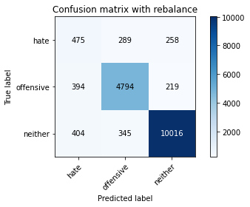

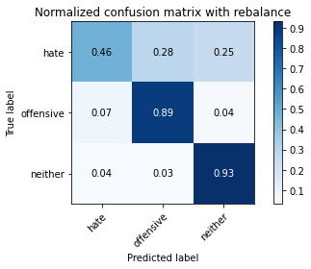

precision recall f1-score support

hate 0.37 0.46 0.41 1022

offensive 0.88 0.89 0.88 5407

neither 0.95 0.93 0.94 10765

accuracy 0.89 17194

macro avg 0.74 0.76 0.75 17194

weighted avg 0.90 0.89 0.89 17194

average eval_loss: 0.4022082968365921, accuracy: 0.8889728975223915

training 5 epoch...

1798.8147151470184 seconds used......

5 training finished! average train loss: 0.2873031156955353

total clf loss: 355.9170406385092 total adv loss: 219.17533241363185 215.84220151306363

evaluating...

Confusion matrix, without normalization

[[ 511 257 254]

[ 432 4704 271]

[ 603 313 9849]]

Normalized confusion matrix

[[0.5 0.25146771 0.24853229]

[0.07989643 0.86998335 0.05012021]

[0.05601486 0.02907571 0.91490943]]

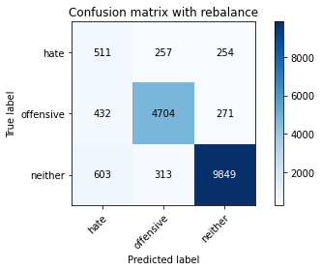

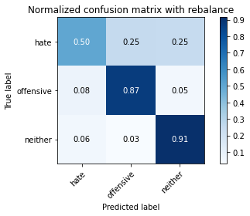

precision recall f1-score support

hate 0.33 0.50 0.40 1022

offensive 0.89 0.87 0.88 5407

neither 0.95 0.91 0.93 10765

accuracy 0.88 17194

macro avg 0.72 0.76 0.74 17194

weighted avg 0.89 0.88 0.88 17194

average eval_loss: 0.4451606438996075, accuracy: 0.8761195765964871

training 6 epoch...

1797.8263382911682 seconds used......

6 training finished! average train loss: 0.2271521011143361

total clf loss: 273.8922143422242 total adv loss: 176.92334147558773 165.9023089860575

evaluating...

Confusion matrix, without normalization

[[ 543 255 224]

[ 568 4595 244]

[ 837 307 9621]]

Normalized confusion matrix

[[0.53131115 0.24951076 0.21917808]

[0.10504901 0.8498243 0.04512669]

[0.07775197 0.02851835 0.89372968]]

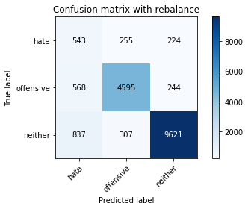

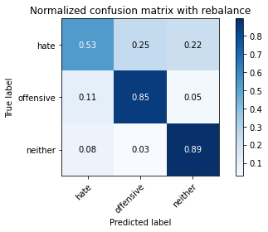

precision recall f1-score support

hate 0.28 0.53 0.37 1022

offensive 0.89 0.85 0.87 5407

neither 0.95 0.89 0.92 10765

accuracy 0.86 17194

macro avg 0.71 0.76 0.72 17194

weighted avg 0.89 0.86 0.87 17194

average eval_loss: 0.5206634369251036, accuracy: 0.8583808305222752

training 7 epoch...

1797.4339575767517 seconds used......

7 training finished! average train loss: 0.19130149760503565

total clf loss: 231.4242667775543 total adv loss: 148.6924052889356 142.59789048796574

evaluating...

Confusion matrix, without normalization

[[ 447 300 275]

[ 379 4733 295]

[ 391 306 10068]]

Normalized confusion matrix

[[0.43737769 0.29354207 0.26908023]

[0.07009432 0.87534677 0.05455891]

[0.03632141 0.02842545 0.93525314]]

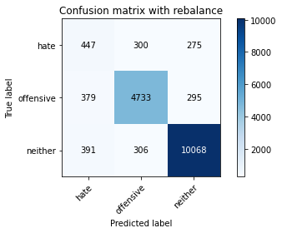

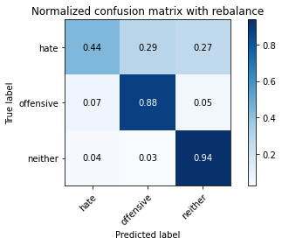

precision recall f1-score support

hate 0.37 0.44 0.40 1022

offensive 0.89 0.88 0.88 5407

neither 0.95 0.94 0.94 10765

accuracy 0.89 17194

macro avg 0.73 0.75 0.74 17194

weighted avg 0.89 0.89 0.89 17194

average eval_loss: 0.5965088745167271, accuracy: 0.8868209840642084

training 8 epoch...

1798.5995738506317 seconds used......

8 training finished! average train loss: 0.17372665448553137

total clf loss: 201.43933269048284 total adv loss: 139.11899833764807 118.49485170139769

evaluating...

Confusion matrix, without normalization

[[ 488 293 241]

[ 449 4718 240]

[ 581 357 9827]]

Normalized confusion matrix

[[0.47749511 0.28669276 0.23581213]

[0.0830405 0.87257259 0.04438691]

[0.0539712 0.03316303 0.91286577]]

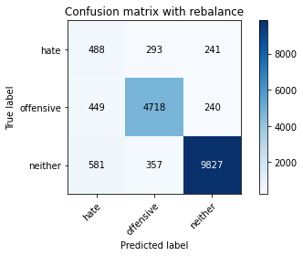

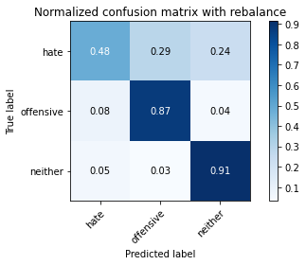

precision recall f1-score support

hate 0.32 0.48 0.38 1022

offensive 0.88 0.87 0.88 5407

neither 0.95 0.91 0.93 10765

accuracy 0.87 17194

macro avg 0.72 0.75 0.73 17194

weighted avg 0.89 0.87 0.88 17194

average eval_loss: 0.5673406467362521, accuracy: 0.8743166220774689

training 9 epoch...

1797.8921234607697 seconds used......

9 training finished! average train loss: 0.1561778048563728

total clf loss: 179.9090631659392 total adv loss: 125.57631709490953 103.29646293464799

evaluating...

Confusion matrix, without normalization

[[ 457 290 275]

[ 348 4725 334]

[ 467 307 9991]]

Normalized confusion matrix

[[0.44716243 0.28375734 0.26908023]

[0.06436101 0.87386721 0.06177178]

[0.04338133 0.02851835 0.92810033]]

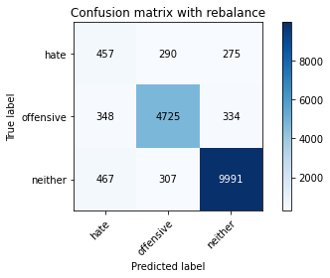

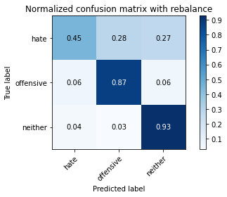

precision recall f1-score support

hate 0.36 0.45 0.40 1022

offensive 0.89 0.87 0.88 5407

neither 0.94 0.93 0.94 10765

accuracy 0.88 17194

macro avg 0.73 0.75 0.74 17194

weighted avg 0.89 0.88 0.89 17194

average eval_loss: 0.5848219128727579, accuracy: 0.8824589973246482

training 10 epoch...

1798.3941986560822 seconds used......

10 training finished! average train loss: 0.14739092100229312

total clf loss: 168.52220540290728 total adv loss: 119.2433009449272 101.4753070585726

evaluating...

Confusion matrix, without normalization

[[ 442 283 297]

[ 416 4744 247]

[ 361 340 10064]]

Normalized confusion matrix

[[0.43248532 0.27690802 0.29060665]

[0.0769373 0.87738117 0.04568152]

[0.0335346 0.03158384 0.93488156]]

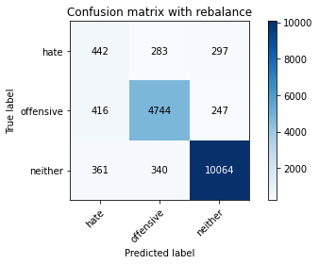

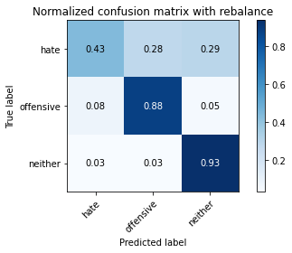

precision recall f1-score support

hate 0.36 0.43 0.39 1022

offensive 0.88 0.88 0.88 5407

neither 0.95 0.93 0.94 10765

accuracy 0.89 17194

macro avg 0.73 0.75 0.74 17194

weighted avg 0.89 0.89 0.89 17194

average eval_loss: 0.6809660162233846, accuracy: 0.8869373037105968

2 run

training 1 epoch...

1776.3969213962555 seconds used......

1 training finished! average train loss: 0.8323066839828764

total clf loss: 1060.7073721885681 total adv loss: 621.3849284113385 675.5380515502766

evaluating...

Confusion matrix, without normalization

[[ 525 251 246]

[ 458 4741 208]

[ 358 306 10101]]

Normalized confusion matrix

[[0.51369863 0.24559687 0.2407045 ]

[0.08470501 0.87682634 0.03846865]

[0.03325592 0.02842545 0.93831863]]

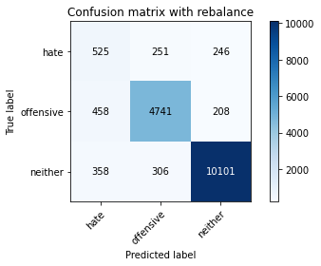

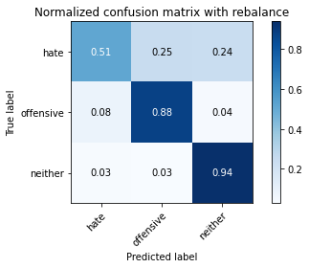

precision recall f1-score support

hate 0.39 0.51 0.44 1022

offensive 0.89 0.88 0.89 5407

neither 0.96 0.94 0.95 10765

accuracy 0.89 17194

macro avg 0.75 0.78 0.76 17194

weighted avg 0.90 0.89 0.90 17194

average eval_loss: 0.3193493665564199, accuracy: 0.8937420030243108

training 2 epoch...

1775.742476940155 seconds used......

2 training finished! average train loss: 0.6461546434793753

total clf loss: 830.8536662571132 total adv loss: 478.5074683728453 516.0978094080929

evaluating...

Confusion matrix, without normalization

[[ 459 294 269]

[ 321 4890 196]

[ 261 351 10153]]

Normalized confusion matrix

[[0.44911937 0.28767123 0.26320939]

[0.05936749 0.90438321 0.03624931]

[0.02424524 0.03260567 0.94314909]]

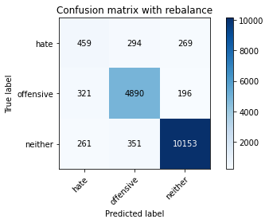

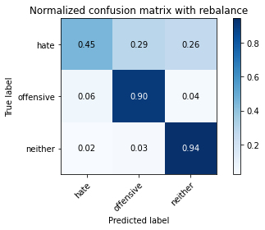

precision recall f1-score support

hate 0.44 0.45 0.44 1022

offensive 0.88 0.90 0.89 5407

neither 0.96 0.94 0.95 10765

accuracy 0.90 17194

macro avg 0.76 0.77 0.76 17194

weighted avg 0.90 0.90 0.90 17194

average eval_loss: 0.3076515861841049, accuracy: 0.9015935791555194

training 3 epoch...

1778.3759565353394 seconds used......

3 training finished! average train loss: 0.5030587338123554

total clf loss: 647.8643854581751 total adv loss: 372.0881167986736 403.9890086611267

evaluating...

Confusion matrix, without normalization

[[ 465 233 324]

[ 372 4682 353]

[ 189 290 10286]]

Normalized confusion matrix

[[0.45499022 0.22798434 0.31702544]

[0.0687997 0.86591456 0.06528574]

[0.0175569 0.02693915 0.95550395]]

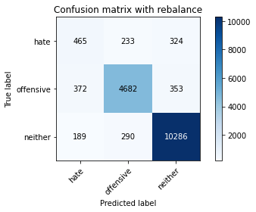

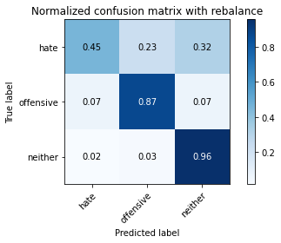

precision recall f1-score support

hate 0.45 0.45 0.45 1022

offensive 0.90 0.87 0.88 5407

neither 0.94 0.96 0.95 10765

accuracy 0.90 17194

macro avg 0.76 0.76 0.76 17194

weighted avg 0.90 0.90 0.90 17194

average eval_loss: 0.34576768352308984, accuracy: 0.8975805513551239

training 4 epoch...

1778.692999124527 seconds used......

4 training finished! average train loss: 0.3653852319582917

total clf loss: 463.2824033384677 total adv loss: 273.6422361826773 283.2269824900868

evaluating...

Confusion matrix, without normalization

[[ 503 285 234]

[ 412 4732 263]

[ 596 347 9822]]

Normalized confusion matrix

[[0.49217221 0.27886497 0.22896282]

[0.07619752 0.87516183 0.04864065]

[0.05536461 0.03223409 0.9124013 ]]

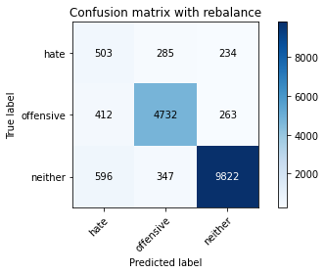

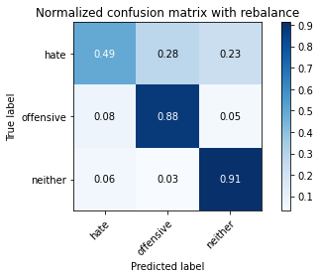

precision recall f1-score support

hate 0.33 0.49 0.40 1022

offensive 0.88 0.88 0.88 5407

neither 0.95 0.91 0.93 10765

accuracy 0.88 17194

macro avg 0.72 0.76 0.74 17194

weighted avg 0.89 0.88 0.88 17194

average eval_loss: 0.4153054223452738, accuracy: 0.8757124578341282

training 5 epoch...

1778.039478778839 seconds used......

5 training finished! average train loss: 0.27271931585764425

total clf loss: 334.3880990864709 total adv loss: 209.89432352572948 209.4234095019492

evaluating...

Confusion matrix, without normalization

[[ 441 269 312]

[ 349 4704 354]

[ 276 289 10200]]

Normalized confusion matrix

[[0.43150685 0.26320939 0.30528376]

[0.06454596 0.86998335 0.06547069]

[0.02563864 0.02684626 0.9475151 ]]

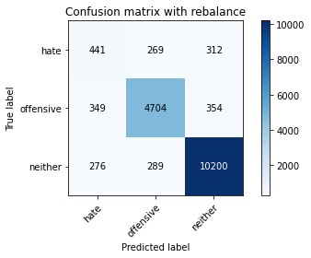

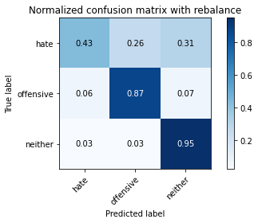

precision recall f1-score support

hate 0.41 0.43 0.42 1022

offensive 0.89 0.87 0.88 5407

neither 0.94 0.95 0.94 10765

accuracy 0.89 17194

macro avg 0.75 0.75 0.75 17194

weighted avg 0.89 0.89 0.89 17194

average eval_loss: 0.46572498903788495, accuracy: 0.8924624869140397

training 6 epoch...